**UNIT1**

1. A hydraulic press exerts a total load of 3.5 MN. This load is carried by two steel rods, supporting the upper head of the press. If the safe stress is 85 MPa and E = 210 kN/mm2,find : 1. diameter of the rods, and 2. extension in each rod in a length of 2.5 m.

2. A steel shaft 35 mm in diameter and 1.2 m long held rigidly at one end has ahand wheel 500 mm

in diameter keyed to the other end. The modulus of rigidity of steel is 80 GPa.

1. What load applied to tangent to the rim of the wheel produce a torsional shear of 60 MPa?

2. How many degrees will the wheel turn when this load is applied?

3. A wall bracket with a rectangular cross-section is shown in Fig. The depth of the cross-section is twice of the width. The force P acting on the bracket at 600 to the vertical is 5kN. The material of the bracket is grey cast iron FG 200 and the factor of safety is 3.5. Determine the dimensions of the cross-section of the bracket. Assume maximum normal stress theory of failure.

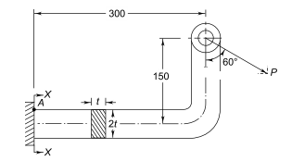

4. a) A shaft is transmitting 50 kW at 80 rpm .Find a suitable diameter for the shaft. If the maximum torque transmitted exceeds the mean torque by 25% take maximum allowable shear stress as 70 MPa.

b) A beam of uniform rectangular cross-section is fixed at one end and carries an electric motor weighing 400 N at a distance of 300 mm from the fixed end. The maximum bending stress in the beam is 40 MPa. Find the width and depth of the beam, if depth is twice that of width

5. a) What factors should be considered in Machine Design?

b) How can you differentiate between Strength and Stiffness?

6. a) State maximum distortion energy theory of failure.

b) List the important factors that influence the magnitude of factor of safety

7. A shaft, as shown in Fig, is subjected to a bending load of 3 kN, pure torque of 1000 N-m and an axial pulling force of 15 kN. Calculate the stresses at A and B.

**UNIT 2**

1. A steel rod is subjected to a reversed axial load of 180 kN. Find the diameter of the rod for a factor of safety of 2. Neglect column action. The material has an ultimate tensile strength of 1070 MPa and yield strength of 910 MPa. The endurance limit in reversed bending may be assumed to be one-half of the ultimate tensile strength. Other correction factors may be taken as follows: For axial loading = 0.7; For machined surface = 0.8 ; For size = 0.85 ; For stress concentration = 1.0.
2. A spherical pressure vessel, with a 500 mm inner diameter, is welded from steel plates. The welded joints are sufﬁciently strong and do not weaken the vessel. The plates are made from cold drawn steel 20C8 (Sut = 440 N/mm2 and Syt = 242N/mm2). The vessel is subjected to internal pressure, which varies from zero to 6 N/mm2. The expected reliability is 50% and the factor of safety is 3.5. The size factor is 0.85. The vessel is expected to withstand an inﬁnite number of stress cycles. Calculate the thickness of the plates.
3. A circular cross section of a bar is subjected to alternating tensile forces varying from a minimum of 300 kN to a maximum of 600 kN. It is to be manufactured of a material with an ultimate tensile strength of 990 MPa and a endurance limit of 770 MPa. Determine the diameter of bar using safety factors of 3.0 related to ultimate tensile Strength and 4 related to endurance limit and a stress concentration factor of 1.6 for fatigue load. Use goodman straight line as basis for design.
4. a) Define the term “Notch Sensitivity”.

b) What is meant by “Stress Concentration”?

c) Explain about methods to reduce stress concentration.

1. a) What are the factors that affect the endurance limit of a machine part?

b) Derive the necessary formula for combined fatigue stresses,

6. A steel cantilever beam, as shown in Fig. 6.21, is subjected to a transverse load at its end that varies from 45 N up to 135 N down as the axial load varies from 110 N (compression) to 450 N (tension). Determine the required diameter at the change of section for infinite life using a factor of safety of 2. The strength properties are as follows: Ultimate strength = 550 MPa Yield strength = 470 MPa Endurance limit = 275 MPa

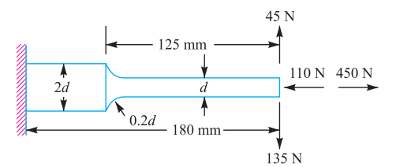

1. A cold drawn steel rod of circular cross-section is subjected to a variable bending moment of 565 Nm to 1130 N-m as the axial load varies from 4500 N to 13 500 N. The maximum bending moment occurs at the same instant that the axial load is maximum. Determine the required diameter of the rod for a factor of safety 2. Neglect any stress concentration and column effect. Assume the following values: Ultimate strength = 550 MPa Yield strength = 470 MPa Size factor = 0.85 Surface finish factor = 0.89 Correction factors = 1.0 for bending = 0.7 for axial load The endurance limit in reversed bending may be taken as one-half the ultimate strength
2. A transmission shaft carries a pulley midway between the two bearings. The bending moment at the pulley varies from 200 N-m to 600 N-m, as the torsional moment in the shaft varies from 70 N-m to 200 N-m. The frequencies of variation of bending and torsional moments are equal to the shaft speed. The shaft is made of steel FeE 400 (S„, = 540 N/mm2 and Sy, = 400 N/mm2). The corrected endurance limit of the shaft is 200 N/mm2. Determine the diameter of the shaft using a factor of safety of 2.

**Unit 3**

1. Compare the weight, strength and stiffness of a hollow shaft of the same external diameter as that of solid shaft. The inside diameter of the hollow shaft being half the external diameter. Both the shafts have the same material and length.
2. The layout of a transmission shaft carrying two pulleys B and C and supported on bearings A and D is shown in Fig. 2. Power is supplied to the shaft by means of a vertical belt on the pulley B, which is then transmitted to the pulley C carrying a horizontal belt. The maximum tension in the belt on the pulley B is 2.5 kN. The angle of wrap for both the pulleys is 180° and the coefﬁcient of friction is 0.24. The shaft is made of plain carbon steel 30C8 (Syt = 400 N/mm2) and the factor of safety is 3. Determine the shaft diameter on strength basis.

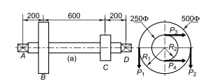

1. A shaft made of mild steel is required to transmit 100 kW at 300 rpm .The supported length of the shaft is 3 metres .It carries two pulleys each weighing 1500 N supported at a distance of 1 metre from the ends respectively. Assuming the safe value of stresses, determine the diameter of the shaft. Take shear stress for the material of the shaft is 60 MPa
2. a) How the shat /axle is designed when it is subjected to bending moment only?
3. What do you know about “Torsional rigidity”? Explain briefly.
4. a) Which theories of failure are applicable for shafts? Why?

b) Define equivalent bending moment in the design of shafts and write down its expression

1. A hoisting drum 0.5 m in diameter is keyed to a shaft which is supported in two bearings and driven through a 12 : 1 reduction ratio by an electric motor. Determine the power of the driving motor, if the maximum load of 8 kN is hoisted at a speed of 50 m/min and the efficiency of the drive is 80%. Also determine the torque on the drum shaft and the speed of the motor in r.p.m. Determine also the diameter of the shaft made of machinery steel, the working stresses of which are 115 MPa in tension and 50 MPa in shear. The drive gear whose diameter is 450 mm is mounted at the end of the shaft such that it overhangs the nearest bearing by 150 mm. The combined shock and fatigue factors for bending and torsion may be taken as 2 and 1.5 respectively
2. A solid steel shaft is supported on two bearings 1.8 m apart and rotates at 250 r.p.m. A 20° involute gear D, 300 mm diameter is keyed to the shaft at a distance of 150 mm to the left on the right hand bearing. Two pulleys B and C are located on the shaft at distances of 600 mm and 1350 mm respectively to the right of the left hand bearing. The diameters of the pulleys B and C are 750 mm and 600 mm respectively. 30 kW is supplied to the gear, out of which 18.75 kW is taken off at the pulley C and 11.25 kW from pulley B. The drive from B is vertically downward while from C the drive is downward at an angle of 60° to the horizontal. In both cases the belt tension ratio is 2 and the angle of lap is 180°. The combined fatigue and shock factors for torsion and bending may be taken as 1.5 and 2 respectively. Design a suitable shaft taking working stress to be 42 MPa in shear and 84 MPa in tension
3. A shaft made of 40 C 8 steel is used to drive a machine. It rotates at 1500 r.p.m. The pulleys A, B and the bearings C, D are located as shown in Fig The belt tensions are also shown in the figure Determine the diameter of the shaft. The permissible shear stress for the shaft material is 100 MPa. The combined shock and fatigue factor applied to bending and torsion are 1.5 and 1.2 respectively.

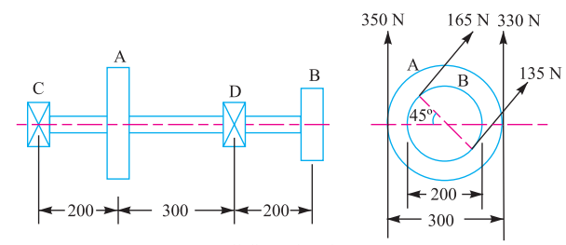

1. The armature shaft of a 40 kW, 720 zpm electric motor, mounted on two bearings A and B, is shown in Fig. 9.12. The total magnetic pull on the armature is 7 kN and it can be assumed to be uniformly distributed over a length of 700 mm midway between the bearings. The shaft is made of steel with an ultimate tensile strength of 770 Nimm2 and yield strength of 580 Nimm2. Determine the shaft diameter using the ASME code if, kb = 1.5 and kt = 1.0 Assume that the pulley is keyed to the shaft.

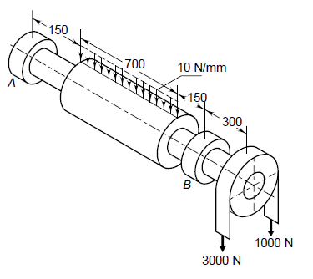

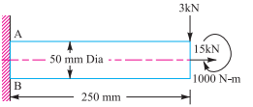

8. A mild steel link, as shown in Fig. 5.24 by full lines, transmits a pull of 80 kN. Find the dimensions b and t if b = 3t. Assume the permissible tensile stress as 70 MPa. If the original link is replaced by an unsymmetrical one, as shown by dotted lines in Fig having the same thickness t, find the depth b1, using the same permissible stress as before.

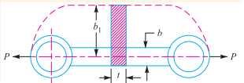

**Unit -4**

1. Design and draw a socket and spigot cotter joint to support a load varying from 30 kN in compression to 30 kN in tension. The material used is carbon steel for which the following allowable stresses may be used. The load is applied statically. Tensile stress = compressive stress = 50 MPa ; shear stress = 35 MPa and crushing stress = 90 Mpa

2. Design a gib and cotter joint with neat sketch, to carry a maximum load of 35 kN. Assuming that the gib, cotter and rod are of same material and have the following allowable stresses: σt = 20 MPa; τ = 15 MPa; and σc = 50 MPa

3. Design a knuckle joint with neat sketch to transmit 150 kN. The design stresses may be taken as 75 MPa in tension, 60 MPa in shear and 150 MPa in compression.

4. Explain the design procedure for Knuckle joint

5 Describe the design procedure for cotter joint with neat sketch

**Unit -5**

1. Find the efficiency of the following riveted joints :

i) Single riveted lap joint of 6 mm plates with 20 mm diameter rivets having a pitch of 50 mm.

ii) Double riveted lap joint of 6 mm plates with 20 mm diameter rivets having a pitch of 65 mm. Assume

Permissible tensile stress in plate = 120 MPa

Permissible shearing stress in rivets = 90 MPa

Permissible crushing stress in rivets = 180 Mpa

2. A tie-bar in a bridge consists of flat 350 mm wide and 20 mm thick. It is connected to a gusset plate of the same thickness by a double cover butt joint. Design an economical joint if the permissible stresses are : σt = 90 MPa, τ = 60 MPa and σc = 150 MPa

3. A bracket is riveted to a column by 6 rivets of equal size as shown in Fig. It carries a load of 60 kN at a distance of 200 mm from the centre of the column. If the maximum shear stress in the rivet is limited to 150 MPa, determine the diameter of the rivet.



1. Explain the design procedure for lozenge joint lozenge joint

5. A steel plate, 100 mm wide and 10 mm thick, is joined with another steel plate by means of single transverse and double parallel fillet welds, as shown in Fig. The strength of the welded joint should be equal to the strength of the plates to be joined The permissible tensile and shear stresses for the weld material and the plates are 70 and 50 N/mm2 respectively. Find the length of each parallel fillet weld Assume the tensile force acting on the plates as static.

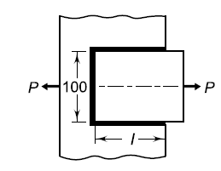

**Unit- 6**

1. A concentric spring for an aircraft engine valve is to exert a maximum force of 5000 N under an axial deflection of 40 mm. Both the springs have same free length, same solid length and are subjected to equal maximum shear stress of 850 MPa. If the spring index for both the springs is 6, find (a) the load shared by each spring, (b) the main dimensions of both the springs, and (c) the number of active coils in each spring. Assume G = 80 kN/mm2 and diametral clearance to be equal to the difference between the wire diameters

2. A helical compression spring made of oil tempered carbon steel, is subjected to a load which varies from 400 N to 1000 N. The spring index is 6 and the design factor of safety is 1.25. If the yield stress in shear is 770 MPa and endurance stress in shear is 350 MPa, find : 1. Size of the spring wire, 2. Diameters of the spring, 3. Number of turns of the spring, and 4. Free length of the spring. The compression of the spring at the maximum load is 30 mm. The modulus of rigidity for the spring material may be taken as 80 kN/mm2.

3. At the bottom of a mine shaft, a group of 10 identical close coiled helical springs are set in parallel to absorb the shock caused by the falling of the cage in case of a failure. The loaded cage weighs 75 kN, while the counter weight has a weight of 15 kN. If the loaded cage falls through a height of 50 metres from rest, find the maximum stress induced in each spring if it is made of 50 mm diameter steel rod. The spring index is 6 and the number of active turns in each spring is 20. Modulus origidity,G = 80 kN/mm2.

4 Design and draw a valve spring of a petrol engine for the following operating conditions :

Spring load when the valve is open = 400 N

Spring load when the valve is closed = 250 N

Maximum inside diameter of spring = 25 mm

Length of the spring when the valve is open = 40 mm

Length of the spring when the valve is closed = 50 mm

Maximum permissible shear stress = 400 MPa

5. In a spring loaded governor as shown in Fig. 23.16, the balls are attached to the vertical arms of the bell crank lever, the horizontal arms of which lift the sleeve against the pressure exerted by a spring. The mass of each ball is 2.97 kg and the lengths of the vertical and horizontal arms of the bell crank lever are 150 mm and 112.5 mm respectively. The extreme radii of rotation of the balls are 100 mm and 150 mm and the governor sleeve begins to lift at 240 r.p.m. and reaches the highest position with a 7.5 percent increase of speed when effects of friction are neglected. Design a suitable close coiled round section spring for the governor. Assume permissible stress in spring steel as 420 MPa, modulus of rigidity 84 kN/mm2 and spring index 8. Allowance must be made for stress concentration, also consider whals shear stress factor